Membership – Meeting Sponsorship Application and Receipt
APPLICATION
Today’s Date:
Applicant’s Name:
Company Name:
Applicant’s Email & Phone Number:
What would you like to sponsor? | Membership Meeting |  |  |  |  | Membership Event |  |  |  |  |  | Other  Othe
What would you like to sponsor? | Please describe:
If you would like to present at a membership meeting, please describe the topic of presentation.
Desired Sponsorship Level: | Bronze ($400) |  |  | Silver ($800) |  |  |  | Gold ($1,200) |  |  | Platinum ($1,600)
Title and Signature:
The Rocky Mountain Chapter of ASSP reserves the right to review, accept or deny all applications for Sponsorship with respect to the best interest of Chapter members.
It is also understood that it is the responsibility of the potential Sponsor to submit the completed Sponsorship Application Form to be considered for approval. If accepted by the ASSP Rocky Mountain Chapter Executive Committee, the sponsor will be provided the benefits outlined in the “ASSP-RMC Sponsorship Levels” based on the level of sponsorship chosen. The Sponsoring Company agrees to the responsibilities of sponsorship as stated within the Sponsorship Opportunities and must submit the required payment based on the level of sponsorship chosen.
Cancellations must be received at least thirty (30) days in advance of the sponsored meeting or scheduled travel to receive full refund. Partial refunds may be provided at the Executive Committee’s discretion for cancellation received less than thirty (30) days prior to sponsored meeting or scheduled travel. In case of meeting/travel cancellation, the full sponsorship fee will be refunded or alternative dates for the sponsorship provided.
To receive full sponsorship benefits (links in email, on website etc.) payment must be received, along with the completed application form, and a minimum of sixty (60) days prior to the sponsored meeting. Please make checks payable to ASSP Rocky Mountain Chapter and send to Chapter Treasurer.
APPROVAL AND RECEIPT
Approved by Chapter Officers Name,
Title and Signature:
Amount Received and Date:

Thank You for your support of the Rocky Mountain Chapter of the ASSP! Your support helps further the occupational health and safety in the Rocky Mountain Region.
Please make checks payable to the “ASSP Rocky Mountain Chapter”
IMPORTANT! We need additional information. Please review and complete the attached form. We will notify you once approved. Please remit fees as early as possible. We need your information before announcements are sent, so please deliver ASAP and no longer than eight (8) weeks prior to the event.

Chapter Representative: Please provide original to the person/company providing support and maintain a copy for Treasurer of the Rocky Mountain Chapter.

The Rocky Mountain Chapter offers four (4) different sponsorship levels. You may select the level that suits your budget and needs.

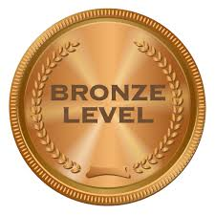  - $400 | One Member Meeting (catering) or One Table at the Member Appreciation Event (portion of catering - 5 Tables available for sponsorship) - Brand placement at Event, Introduction at Event, and One-Month Sponsor Thank-You with Logo on our Sponsorship Page - same Month as event sponsored.
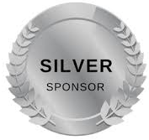  - $800 | OSHA 10-hour Certification for students (General Industry or Construction) and Two-Month Sponsor Thank-You with Logo on our Sponsorship Page.
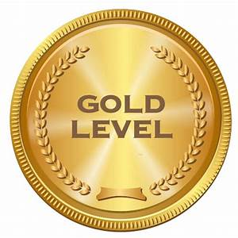  - $1,200 | Premium Placement at Member Appreciation Event and Three-Month Sponsor Thank-You with Logo on our Sponsorship Page
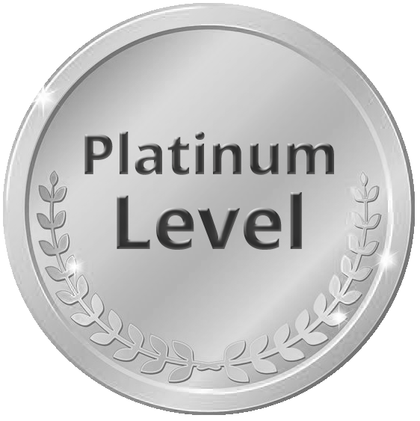  - $1,600 | Sponsor of the Year- Sponsor a Region 2 Super Meeting hosted by Rocky Mountain Chapter (Brand visibility throughout the Western US) and Twelve-Month Sponsor Thank-You with Logo on our Sponsorship Page

- Please supply your logo in JPG format, ready for display.
- Links may only lead to a home web page your organization owns; no links to third-party sites or pages
- Please complete the attached form and submit it with any other relevant information. The Chapter reserves the right to edit for content and disallows any language that is objectionable, at its
*SERVICES LISTED ABOVE ARE APPLICABLE TO TECHNICAL MEMBER MEETING DATES WHERE AN IN-PERSON MEETING IS HELD AT A MEETING VENUE LOCATION.

Sponsor’s signature above indicates consent and approval for the ASSP Rocky Mountain Chapter (the Chapter) to place sponsor’s name, logo and submitted text, documents, and information with website links on the Chapter’s web page and in Chapter e-mails in accordance with the requirements and limitations herein.
Sponsor acknowledges and agrees that the Chapter may disapprove of any ads that do not meet its content guidelines. Sponsor understands and agrees that the Chapter may need to cancel the Sponsored meeting for convenience or act of God; in the event of any such cancelation, the Chapter will refund the Sponsor fee, if any paid, but shall have no other obligation to Sponsor.
The Sponsor will not knowingly provide information, documents or links that are political in nature, racist, controversial or that promote services or good by a third-party or that infringe upon or violate any proprietary rights of any third party, including, without limitation, any copyright, trademark, known patent or trade secret right.
In the event that the Chapter discovers, or is informed by a third party, that the Content provided by the Sponsor infringes upon that third-party’s intellectual rights, the Chapter will notify the Sponsor and will remove the Content from the Chapter website and e-mails and, if such infringement is discovered after the date of the Sponsored meeting, the Sponsor shall not receive a refund of its sponsorship fee.
To the fullest extent permitted by law, the Sponsor agrees to indemnify, defend and hold the Chapter, the American Society of Safety Professionals, their affiliates, subsidiaries, and each of their respective officers, directors, partners, employees and agents harmless from and against any liability, losses, damages, expenses (including reasonable attorney’s fees), orders, penalties, claims, demands and actions of any nature whatsoever (collectively “Losses”) which arise out of or are otherwise related to (i) the negligent acts, acts of emission, or intentional acts of the Sponsor or its employees, (ii) any breach of the provision of this agreement, (iii) any violation of federal, state or local law and/or (iv) any allegation that the Content provided to the Chapter infringes on any patent, trademark, copyright trade secrete right or similar allegation.

